Climate Budgeting Examples

2022 Malaysia Public Expenditure Review

Climate Change Budget Tagging: A Review of International Experience
Climate expenditures are generally tagged during budget preparation providing information on allocations. Rarely do they cover actual expenditures. Climate budget tagging methodologies include three essential design elements: definition of climate-relevant expenditure; definition of appropriate coverage; and estimation of climate-relevant spending. Countries have defined climate-relevant activities and expenditures based on objective or intended impact of an activity (e.g., Rio Markers or World Bank taxonomy) or based on the country’s climate policies.
All PERs have included both adaptation and mitigation actions and almost all include central government recurrent and investment budgets. Few PERs have included expenditure with adverse impacts on climate change tax expenditures. The sectoral coverage of PERs is often limited to the most climate relevant sectors, but in a few instances, have included all sectors and state-owned enterprises (SOEs). A few PERs have also included local government expenditures. Countries have estimated climate-relevant expenditures by either applying climate-relevance weights to program or project expenditures, or by estimating the expenditures associated with the climate relevant elements of a program activity. All three elements require informed judgments. Typically, tagging methodologies are developed by finance or planning agencies in coordination with specialized environment and climate change agencies, and are applied by line ministries and agencies. Some countries also have procedures to review and validate tagged expenditures.

C40 Cities Climate Leadership Group Knowledge Hub
(Climate Budgets (c40knowledgehub.org))
A climate budget is a governance system that offers a way for cities to turn climate commitments into funded and measurable actions across city government. It embeds climate targets, measures and considerations into decision-making as part of a city’s ordinary budgeting process. Crucially, it ensures that Chief Financial Officers take responsibility for delivering the city’s climate targets.
Led by the City of Oslo, which first pioneered this approach in 2017, a group of cities are working together to develop ways to replicate and adapt climate budgeting to their own contexts. Some, including Barcelona, Berlin, London, Montréal, New York City, Paris, Stockholm and Tshwane, are already creating full climate budgets or developing key elements of the approach, which can be adopted and adapted by cities of every size and on every continent.

City Case Study: Oslo – Institutional Coordination Through the Climate Agency
In Oslo, the Mayor has overall responsibility for driving action on climate change, the Vice Mayor of Environment is responsible for climate action planning and execution, and the Vice Mayor of Finance is responsible for the city’s climate budget. The Climate Agency was established to help the city to achieve climate goals and promote cross-sectoral initiatives, acting as an influencer and coordinator. It calculates emission reductions from proposed measures, offers technical support and advice to all stakeholders and is responsible for drafting the climate budget text. To support departments in developing and submitting proposed measures, the agency issues budget instructions with guidance and templates.

Monitoring, Reporting and Evaluation
Oslo provides MER instructions in grant letters sent out at the beginning of the budgetary cycle, which include proposed key performance indicators (KPIs) and targets for each action in the climate budget, as well as the budget reporting and instructions. Reporting to the city council is presented using a traffic-light system that identifies each action as being on track, in progress or delayed, based on targets and KPIs, as well as a sector-level ‘climate barometer’ that assesses actual emission reductions against projections. For example, transport indicators include electric vehicle sales and shares, vehicles through the toll rings and public transit usage.

City Case Study: Mumbai – Strategic Planning through the Climate Action Plan
In March 2022, Mumbai launched its first Climate Action Plan (MCAP). The MCAP sets out a clear vision for and political commitment to climate action and identifies climate budgeting as ‘essential for Mumbai to ensure that dedicated financial resources are available to implement MCAP and to leverage this as a governance tool to overcome institutional barriers identified in the city’s existing governance structure’ (p. 195). The MCAP also proposes a ‘climate cell’ to develop and support this work, with a mandate to support the successful implementation of the MCAP.

City Case Study: London – Taking a Phased Approach to Implemeting Climate Budgeting
In July 2022, London incorporated the concept of climate budgeting into its budget guidance for 2023-24 and related steering documents, spelling out for the first time how spending would be linked to the commitment to make London net zero by 2030 and the responsibilities of all underlying agencies. London is taking a phased approach to introduce climate budgeting, starting with municipal emissions before rolling out with the city’s borough councils and finally the whole geographic area.
Each agency is required to explain in its budget submission: the scope of its climate budget; historical greenhouse gas emissions; the status of climate measures already being delivered; projected emissions (to 2030) with funded measures and unfunded measures; estimated residual emissions in 2030; co-benefits associated with planned climate actions; and uncertainties. London has also established a cross-departmental climate budgeting working group. Once climate budget submissions have been received and reviewed, the team leading the climate budget process considers ways to improve the approach and seeks feedback from the working group.

Aligning Regional and Local Budgets with Green Objectives: Subnational Green Budgeting Practices and Guidelines
State of play: Subnational green budgeting practices in OECD and EU countries
In recent years, as an ever-growing number of regions and cities have set ambitious climate and environmental targets, the interest in subnational green budgeting has also grown steadily as has the number of subnational governments implementing green budgeting practices. A stocktake of existing subnational green budgeting practices in OECD and EU countries found that green budgeting encompasses a variety of practices including carbon budgets, ecoBudgets, climate budgets, environmental and climate impact analyses, and more. Among the countries identified in the stocktake as having subnational green budgeting exercises, France stands out for having a large number of green budgeting exercises at all three levels of subnational government. Other interesting exercises were identified in Austria, Italy, Norway, Spain and the United Kingdom.

Country Case Study: France – Regional Green Budgeting
In France, green budgeting practices have emerged at all subnational levels: regional, departmental, and municipal. At the regional level, the regions of Brittany, Grand-Est, and Occitanie have launched a green budgeting practice. The three regions use a common green budget tagging methodology to assess the climate adaptation and mitigation impact of their budgets. The methodology was developed by the Institute for Climate Economics (I4CE) and was inspired by the green budget tagging methodology used at the national level in France.
The purpose of the methodology is to assess the climate adaptation and mitigation impact of all regional expenditure and to incorporate this information into future budgetary decisions. Ideally, the methodology should be applied to the entire budget, however, when starting out it is suggested that as a minimum the analysis should assess current and capital expenditure in the main budget, special budgets, and any delegated public service provision contracts. Revenues are not currently covered by the methodology as subnational governments in France have limited revenue autonomy; however, I4CE notes that they could be incorporated in the future. The methodology can be applied to both draft budgets and closed administrative accounts, in other words it can be applied ex ante and ex post.
An analysis of the climate impact of expenditure using the I4CE methodology takes place in two steps:
- The first step is a high-level analysis of all the expenditure items to classify them into three categories: those with a neutral climate impact, those lacking sufficient information to be classified (labelled “undefined” in the I4CE methodology), and those to be further analysed for their climate impact (labelled “to analyse”).
- The second step is applied only to those expenditures classified as “to analyse” by the first step. This subset of expenditures is further analysed according to their climate impact using “structuring hypotheses” and a colour-coded grade scale ranging from favourable to unfavourable

Country Case Study: Scotland – Carbon Impact Assessment
Scotland’s green budgeting practice uses a form of environmental impact assessment to analyse the carbon footprint of all goods and services purchased by the Scottish government’s annual budget. Based on Section 94 of the 2009 Climate Change (Scotland) Act, a “Carbon Assessment” is included alongside the draft budget, detailing the emissions impact of expenditure proposals within the budget. By including this statement within the draft budget, Scotland is also using the green budget statement tool.
The Carbon Assessment covers direct emissions (e.g., emissions from the generation of electricity consumed by the government) and imported emissions that are generated outside of Scotland in producing the direct and indirect goods and services that the government purchases. The Assessment, however, does not account for “second-round” emissions. For example, the emissions generated from constructing a road paid for by the government would be assessed but the emissions generated from the cars using the road would not be accounted for. Within the annual report, the emissions estimates are broken down by spending portfolio (e.g. justice, health and sport, education and skills, etc.) and by industry (energy, water, and waste; manufacturing; agriculture, forestry, and finishing; etc.) to provide information on which area of spending generates the most emissions. Additionally, data is provided on the total emissions per type of expenditure (current versus capital).

Region Case Study: Sardinia (Italy) – Annual Green Analysis
The region of Sardinia’s (Italy) approach to green budgeting is centred on an annual analysis of its environmental protection and natural resource use and management expenditure. Sardinia was inspired by the national-level green budgeting practice conducted annually by the Italian government, which also tracks environmental protection and natural resource use expenditure.
Implemented for the first time in 2019, the exercise tracks both current and capital expenditures at the level of each individual budget chapter, reconciling the expenditure by missions, programmes, and codes for environmental protection expenditure and natural resource use and management expenditure, respectively. Tracking is carried out on the draft budget and therefore the results show the forecasted expenditure in these two areas for a given year.
Climate-favourable expenditures are tagged for a list of 13 sectors that include forest management and use, inland water sources management and use, protection and rehabilitation of soil, subsoil and surface water; wastewater management, research and development, and waste management.
The data collected from this exercise is used to produce a report with graphs showing the breakdown of forecasted expenditure by sector, by type of expenditure (capital or current), and by government department. In 2021, the region’s environmental protection and natural resource use and management expenditure totalled nearly EUR 790 million across nine sectors.
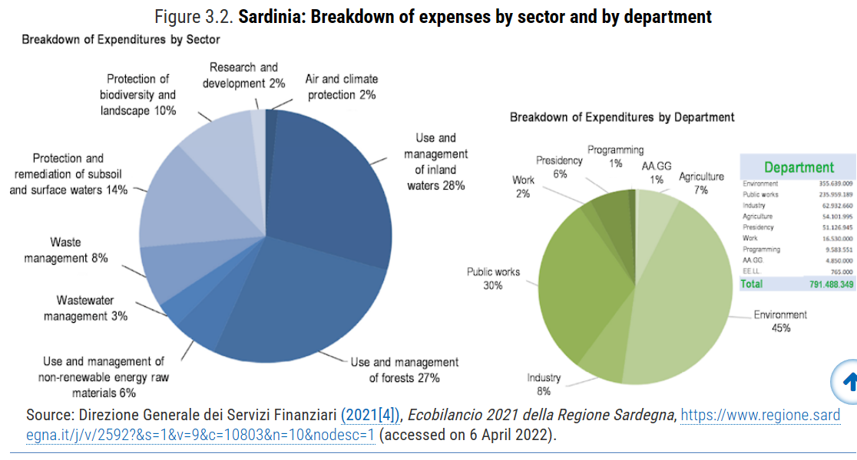

Region Case Study: Andalucia (Spain) – A Multifaceted Approach
The autonomous region of Andalusia, Spain was the first Spanish region to adopt green budgeting, in 2018, and the only subnational green budgeting practice identified in this stocktake to have made green budgeting mandatory by regional law. Andalusia’s green budgeting practice is predicated on a regional strategy to integrate a green perspective into all aspects of regional strategic planning, which itself serves as guidance for the region’s budgetary decision-making. Moreover, in developing its green budgeting practice, Andalusia is building on its well-established gender budgeting practice, dating back to 2004, and which the region intends to link with their green budgeting approach given that the impacts of climate change affect men and women differently and require public action that takes this into account in order to ensure a just transition.
Andalusia’s green budgeting practice is multifaceted and includes climate impact assessments, green budget tagging, and environmental tax reform, among other aspects. The 2018 Andalusian climate change law set outs two key aspects of the region’s green budgeting approach: budgetary climate indicators and climate impact assessments for regional and local planning and strategy documents:
- The law stipulates that the region is to develop climate change budgetary indicators to measure and track the impact of budget programmes on climate change adaptation and mitigation, and that the Budget Department is to prepare an annual report tracking the evolution of these indicators. In the 2021 budget, more than 60 climate change indicators were presented to identify the climate impact of budget measures.
- The second key aspect is a multi-step climate impact assessment for regional and local plans and programmes thought to have an impact on climate change and the clean energy transition. Plans and programmes identified as having a climate change impact must include five elements as part of their proposal:
- A climate change vulnerability analysis from an environmental, economic, and social perspective.
- Steps to promote medium- and long-term climate change mitigation.
- Justification of how the plan or programme aligns with the Andalusian Plan of Action for the Climate.
- Indicators to evaluate the climate impact of the plan or programme.
- An analysis of the potential direct and indirect impact of the plan or programme on energy consumption and greenhouse gas emissions.
An additional aspect of the region’s green budgeting practice is the EUR 1 million Green Budget Fund set up to fund projects that integrate a green perspective into the region’s budget. Among all levels of government practising green budgeting in the OECD and EU, Andalusia is the only one to have established such a fund.
Andalusia is also currently collaborating with DG REFORM of the European Commission to develop two additional aspects of their green budgeting practice. Firstly, the Region has developed a Sustainable Finance Framework to serve as the basis for issuing sustainable bonds to fund green and social projects. Part of developing this framework included implementing green budget tagging within the regional budget in order to identify projects to be funded using the proceeds of sustainable (green and social) bond issuances.
The final aspect of Andalusia’s green budgeting practice is environmental tax reform. As part of a second ongoing DG REFORM project, the region is collaborating with the OECD to design, develop, and implement tax reforms in four green domains: climate change and air pollution; electricity usage; water pollution; and circular economy. The project aims to provide recommendations to Andalusia so that it can plan potential adjustments to its environmental and climate relevant tax legal framework, with a view to improving regional green outcomes and strengthening contributions to national and global performance.

Region Case Study: Catalonia (Spain) – Climate Budget Tagging
The Catalonian government recently released the results of its first climate budget tagging practice in March 2022. The regional government chose to base their methodology on the European Commission’s climate tagging methodology, which uses the OECD DAC Rio Markers and a set of climate coefficients.
Catalonia’s methodology analyses the climate adaptation and mitigation impact of budget programmes, based on their stated objective. The methodology consists of three steps. The first step analyses whether each programme’s strategy is in line with Rio Markers’ eligibility criteria. Expenditures that do not meet these criteria are labelled as “not targeted”, with a score of 0 points. Expenditures that meet Rio’s eligibility criteria are further classified based on whether they contribute to mitigation or adaptation objectives. Then, the second step consists in determining the degree of contribution of the expenditure to the corresponding marker. Expenditure programmes that are essentially oriented towards the objective set by the Rio Marker are allocated 2 points (“Main”). Expenditure whose objectives are only partially aligned with Rio Markers are allocated 1 point (“Significant”).
Finally, the third step consists in translating the results into a percentage of analysed expenditure that can be considered significant in terms of fighting against climate change. While there is no detailed methodology to derive coefficients from the Rio Markers, Catalonia followed the convention set up by the European Commission, which stipulates that 100% of expenditure with a score of 2 should be counted, 40% for expenditure with a score of 1, and 0% for expenditure lines with a score of 0. Based on this methodology, it was estimated that 19.8% of Catalonia’s 2022 Budget Programme contributes to the fight against climate change (corresponding to 21 budget programmes, 12 focused on mitigation and 9 focused on adaptation)

